Game Design Document

Fill up the following document

1. Write the title of your project.

Ludo Game

1. What is the goal of the game?

To get all your characters into the center and stop the others to do the same

1. Write a brief story of your game.

Ludo is a board ganme which doesn’t have a story. It became popular during the pandemic due to the rise of online versions such as ludo king.

1. Which are the playing characters of this game?

* Playing characters are the ones who respond to the user based on the input from the user.
* Cars, monkeys, dinos, wizards, etc., are the playing characters in the game.

|  |  |  |
| --- | --- | --- |
| Number | Character Name | What can this character do? |
| 1 | Red player | Move along the board |
| 2 | Blue player | Move along the board |
| 3 | Green player | Move along the board |
| 4 | Yellow player | Move along the board |

1. Which are the Non-Playing Characters of this game?

* Non-Playing characters are the ones that don't have an action or behavior when the user interacts with the game.

This game has no non-playing character as it is a board game with 4 real players

Draw your imagination of this game. What does this game look like?

* Draw the game either on your computer or on paper.
* Add images of the game scenes to show each of the playing and non-playing characters at least once.

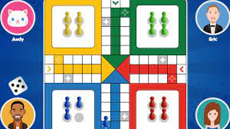

The photo on the left shows this game in action with the board, the dice and the player with their icons.

How do you plan to make your game engaging?

This game can be made engaging by slightly tweaking the rules of ludo to allow different variations so that it isnt repetitive or the same as others.